1. **Evaluation**

Table 4.1. Technical Design Constraints

|  |  |
| --- | --- |
| **Name** | **Description** |
| Hand Orientation | The glove must determine the angles of wrist flexion, extension, and deviation within a 3° margin of error. Also, the glove must measure wrist acceleration, hand orientation, and hand acceleration within a 5% margin of error. |
| Wireless Communication | The wrist-mounted controller must communicate wirelessly with a range that will span the average width of a tee box: 30 feet. |
| Data Display | The system must communicate its measurements to a visual application that will display these metrics through a simple interface. The data can be analyzed after recording a swing, or real-time with both modes supporting a data rate of 100 hertz. |
| Unobtrusive | The user must not be obstructed while gripping the club with the glove on. The wrist-mounted computer must have a footprint smaller than the average sweat-band size of 3 inches. The sensor wires in the glove must not interfere with swing motion. |
| Portability | The wrist-mounted controller must be battery powered and not require manual calibration on start-up. The minimum battery life of the system must exceed 5 hours of use. |

* 1. **Hand Orientation**
     1. **Test Certification - Accelerometer**

The accelerometer was tested by completing two tests. First, the accelerometer was tested to ensure that the device was able to properly send data that could be read by the microcontroller. This test was completed using an arduino IDE and using the serial plotter to show the different sensor values (Figures X, X, Y, Z).

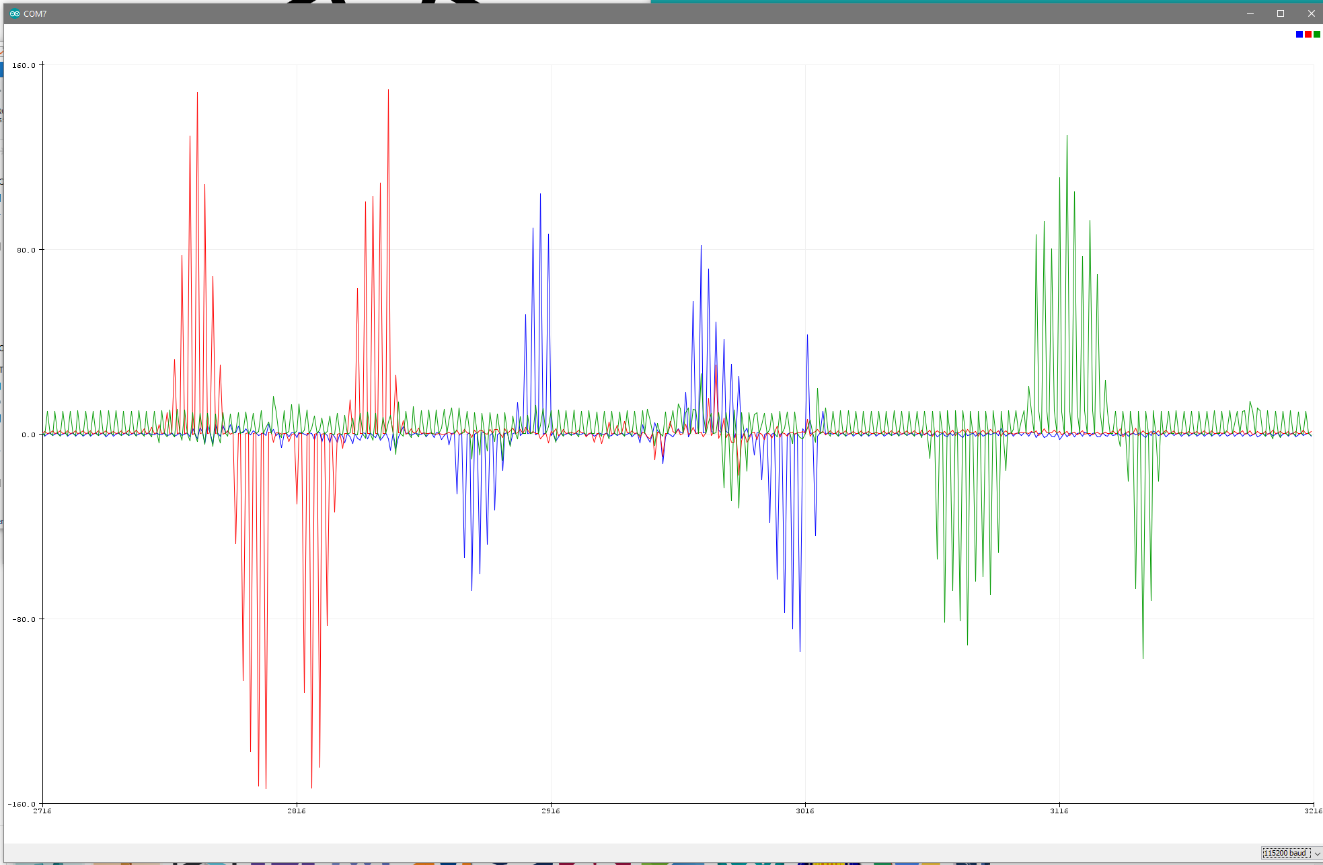

Figure X

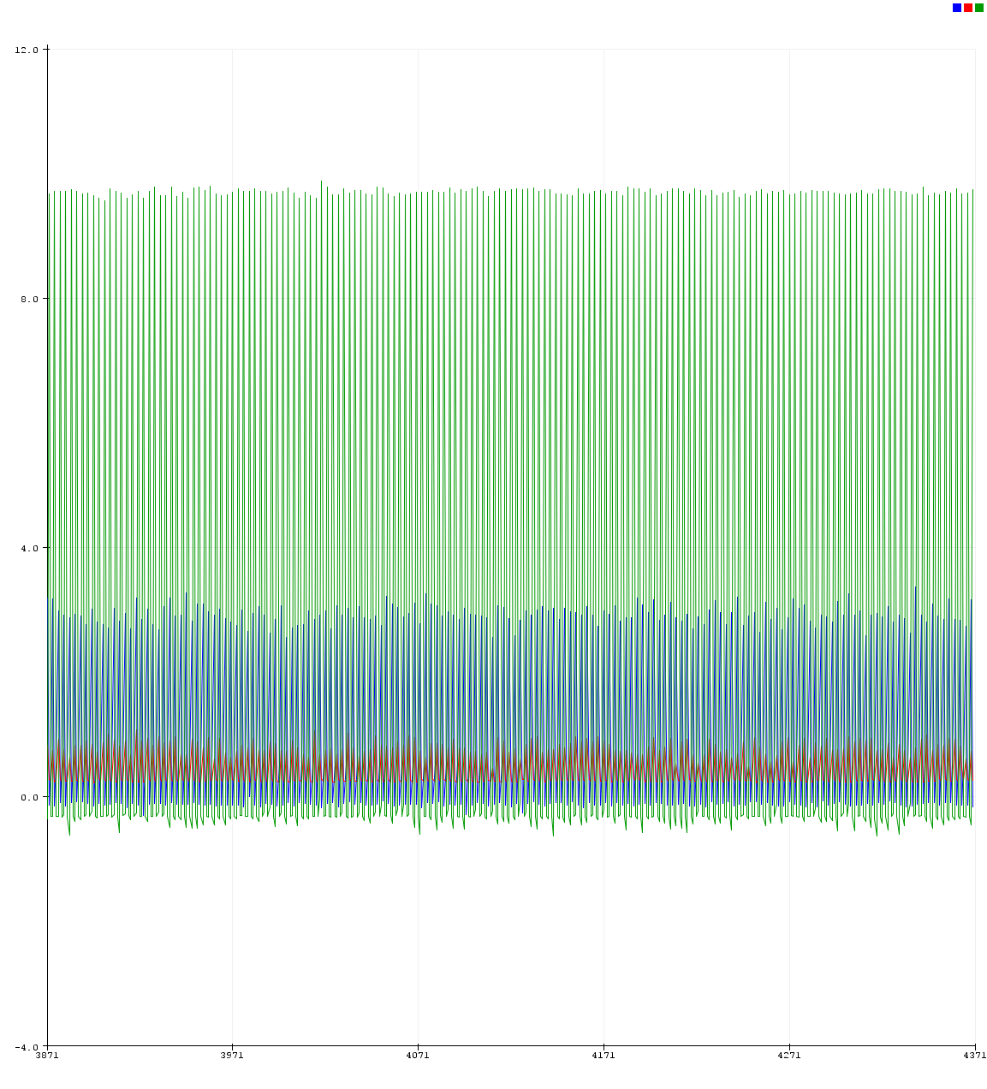

Figure X

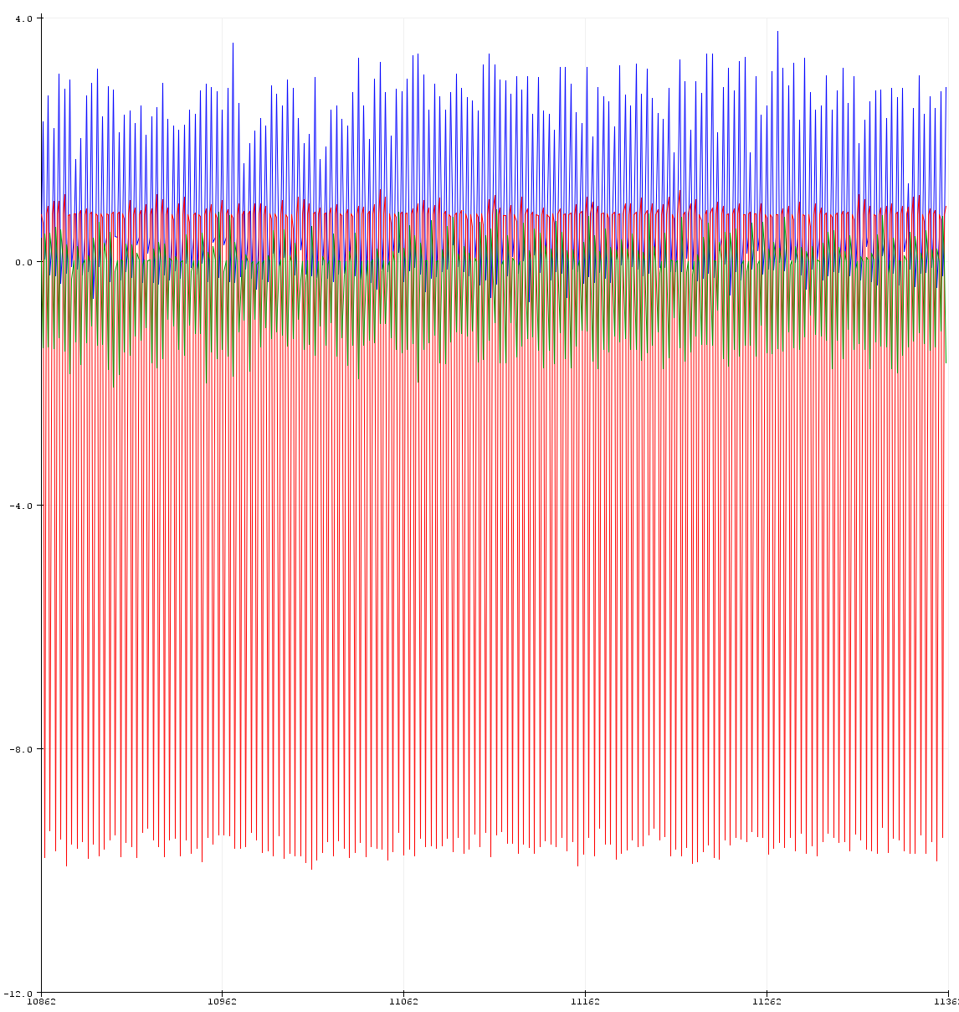

Figure Y

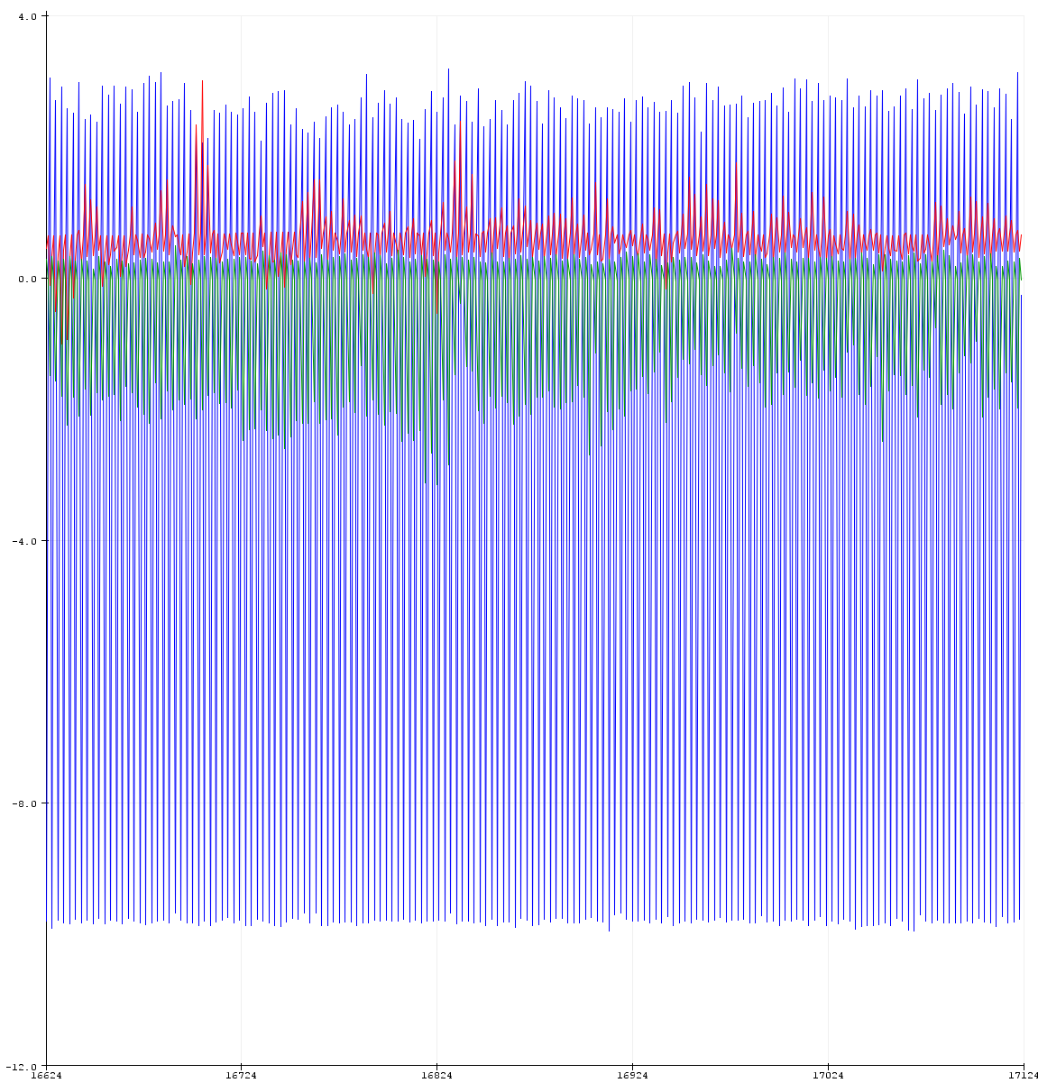 Figure Z

The next step was to ensure that the accelerometer was giving the correct readings, the accelerometer was placed inside of a 3D printed cube to ensure flat sides on every axis. The accelerometer was placed on the respective XYZ sides of the cube and the value was recorded. The following plotted graph shows the values as each side was placed onto a flat surface (Figures X, Y, Z).

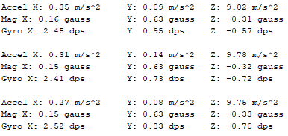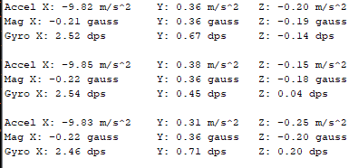

Figure X Figure Y

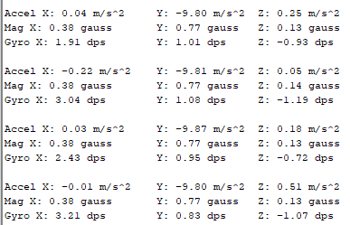

Figure Z

* + 1. **Test Certification - LiquidWire**

The liquid wire was tested by completing two tests. First the sensors were attached to a digital multimeter and the resting resistance was recorded (Figure X.X).

Next, the sensors were set at rest and the resistance was recorded.

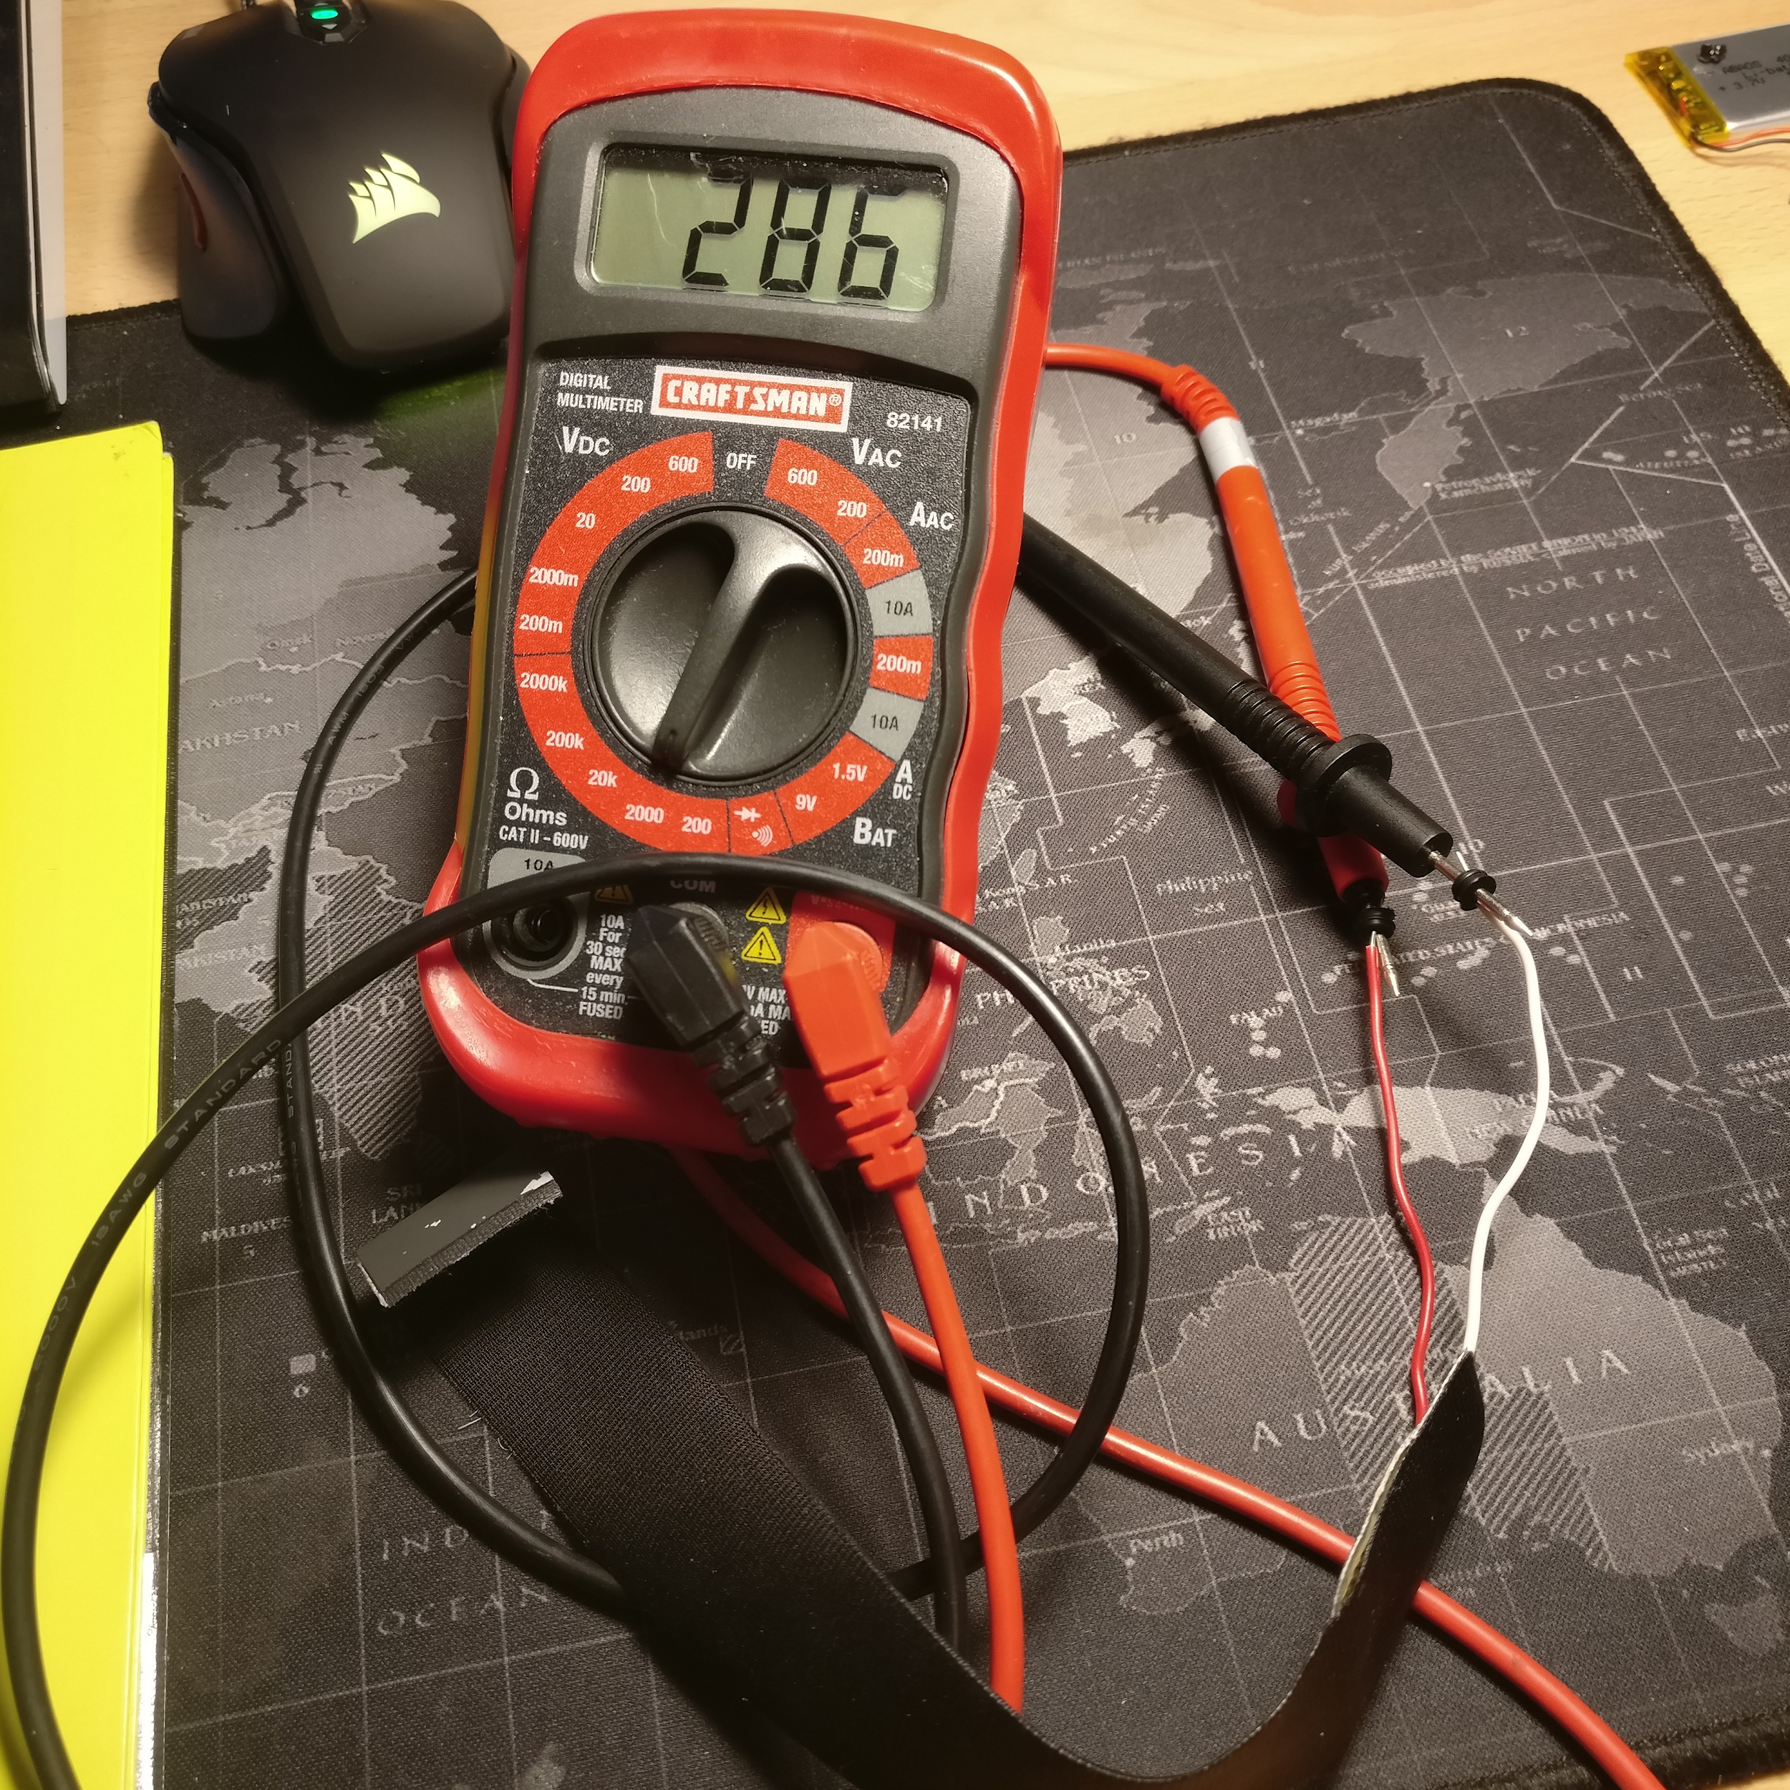

Figure X.X

Next a sensor was placed on a testing apparatus that emulates the motion of a wrist (Figure Y.Y). The lever of the apparatus was then slowly pressed from it’s 45 degree resting position to the final resting position at 0 degrees. Below is a graph of the sensor data during this test (Figure Z.Z):

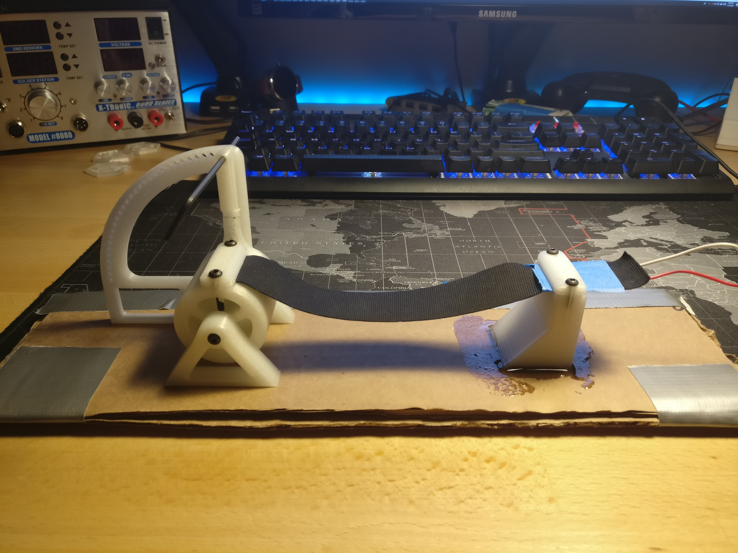

Figure Y.Y

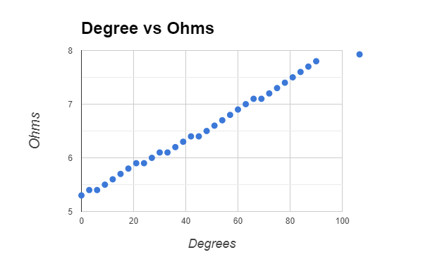

Figure Z.Z

* + 1. **Test Certification - Pressure Sensor**

To test the pressure sensor two tests were completed. First a single sensor was placed onto a flat surface and the leads connected to a resistor divider. The sensor was then pressed by a finger and the data was recorded in the below graph (Figure X.X): (This data will show that a sensor is able to detect changes in pressure.)

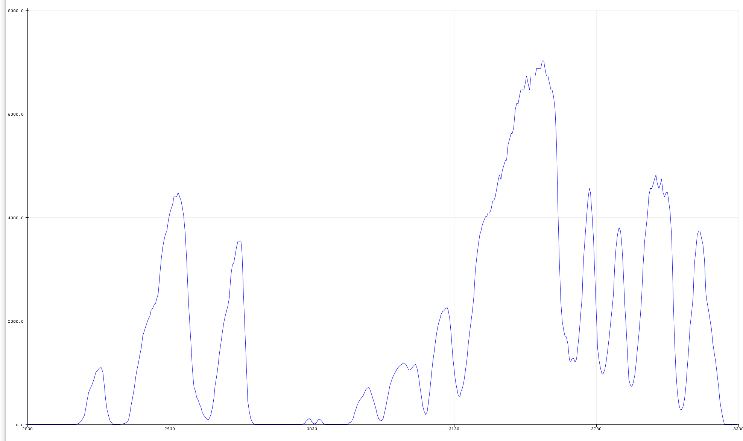

Figure X.X

Next the pressure sensor was connected to a multimeter and placed onto a 50 lb scale. a printed platform was placed onto the pressure sensor with a container of water. Water was added in 200 gram increments and the resistance was recorded at each weight measurement. The following is a graph of the obtained data (Figure Y.Y):

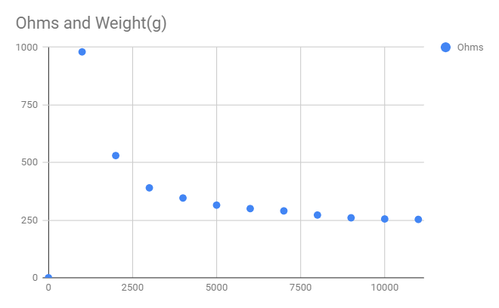

Figure Y.Y

* 1. **Wireless Communication**
     1. **Test Certification - Microcontroller Bluetooth Broadcast**

The wireless communication test consists of loading the Cypress Bluetooth firmware for the device onto the CYW20719 development board and using the Cypress CySmart Android mobile application to receive data from the development board. Using a mobile phone, a Bluetooth connection will be established between the devices and the GATT protocol implementation will be tested using the CySmart application.

|  |  |  |
| --- | --- | --- |
|  |  |  |

Figure A.A: Cypress CySmart application screenshots showing BLE interaction with device.

* + 1. **Test Certification - Desktop Bluetooth Reception**

The desktop bluetooth reception was tested using a Raspberry Pi with a Bluetooth 4.1 chipset. Using *noble* as the backbone for the reception software, a Node.js server was initialized and requested to start scanning for BLE signals. Below in Figure B.B is a screenshot of server’s console during this test.

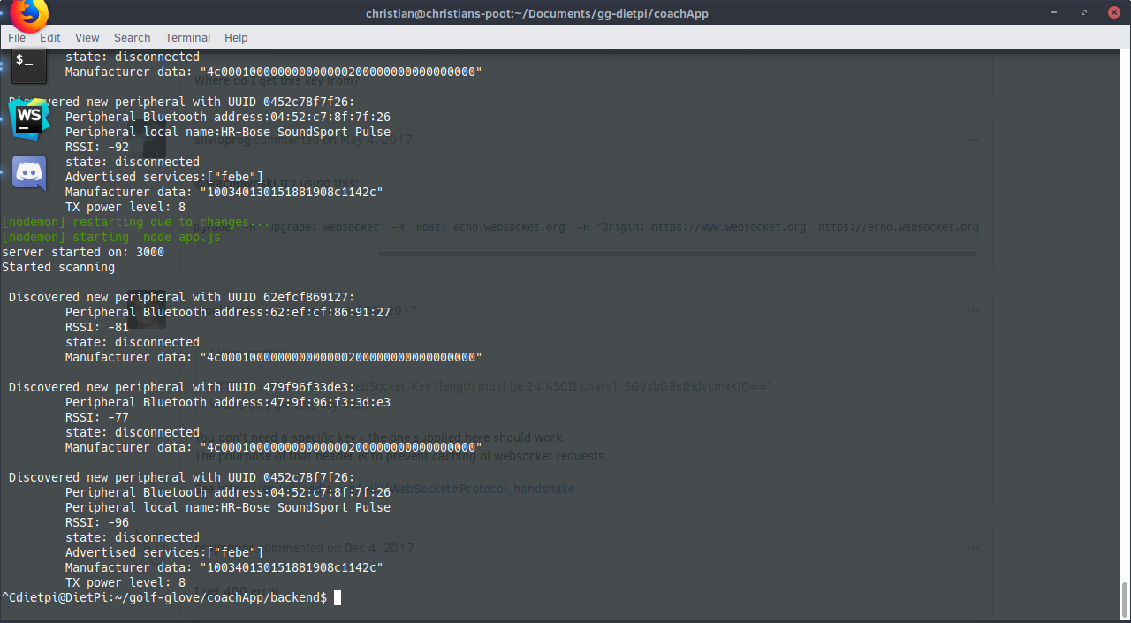

Figure B.B.

* 1. **Data Display**

Testing the data display requires access to a dataset to display. Since the Golf Glove system is not yet completely integrated, the data display is tested using a dummy dataset. Figure Gui.Gui shows an unpolished graph of what acceleration may look like at a slight acceleration in the y direction. Further refinement will include indicating which lines correspond to each data point via a legend.

* + 1. **Test Certification – GUI Screenshot**

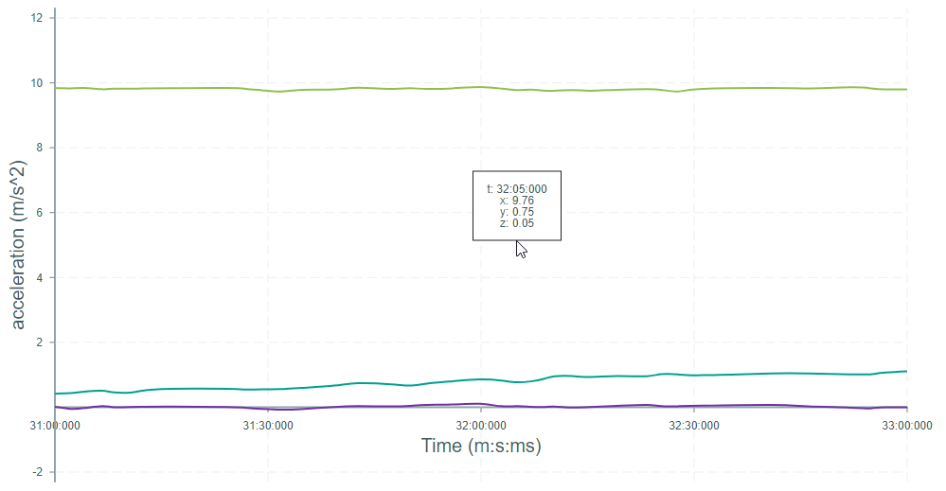

Figure Gui.Gui. Bare-bones Graph

* 1. **Unobtrusive**

The microcontroller is currently being developed and tested on a development board. The design plans in further iterations will use a custom PCB, reducing the module’s size. Figure C.C is a sketch of the final wrist mounted controller footprint.

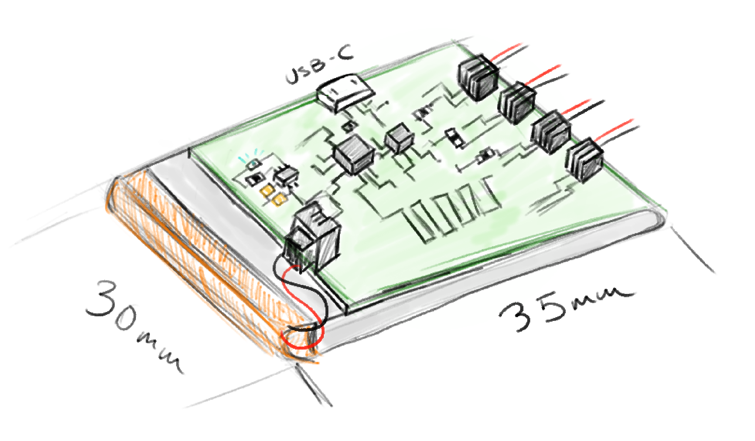

Figure C.C. Sketch of Final Wrist-mounted Controller

* + 1. **Test Certification – Wrist Width**
  1. **Portability**

Todo: These two subsections will test whether the controller can operate without user calibration on startup, as well as testing whether the system can last 5 hours.

* + 1. **Test Certification – Calibration**
    2. **Test Certification - Battery**
  1. **Integrated System**

Todo: These two subsections will test whether the data is sampled rapidly and accurately enough, as well as testing the communication fidelity of the controller to the receiver.

* + 1. **Sampled Data Rate**
    2. **Communication**

1. **Summary and Future Work**

Todo: this will be completed after the design is ready.

1. **Acknowledgements**

Thank you to Dr. John Ball for being an excellent advisor.

1. **References**
2. **Appendix: Product Specification**

